Opening the Calculator

1. Download all the files from the google drive folder.
2. Find the location of the folder in files on the computer
3. Click on any HTML link within the folder and it will open up to the calculator.

Clearing the Calculator Data

1. Right click and click on “Inspect element”
2. In Firefox: click on the console tab which will be in the top bar next to Inspector.
   1. In the “>>” bar on the the bottom type the following:
      1. localStorage.removeItem(“inputData”)
         1. Then hit enter and make sure it says “undefined”
      2. localStorage.removeItem(“resultsData”)
         1. Then hit enter and make sure it says “undefined”
   2. Then exit out of the console and refresh the page and both “Time Back to Zero” and “Tiny House Carbon Footprint**”** part should be zero.

Modifying and Adding Products to the Calculator

1. Open up the .js file in files/finder on the computer (not any of the html) and open it with Sublime - a text editing app.
2. In order to modify any carbon values for an already given material:

Ctrl (or command for Mac) F and type in the key word of the material you are looking for. Then simply modify the purple number corresponding to the specific option. (Make sure the number stays purple.)

Example: You want to change the carbon content of General Paint.

Ctrl F and type in “paint” - then see where it says “General” in the first set of curly brackets and change the number in purple. 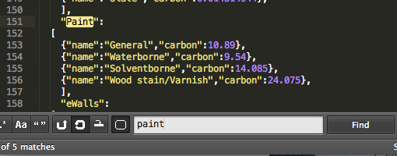

In this case you would change the “10.89” to the desired number.

2. In order to add a whole new option:

* Keep the syntax the same.
* A new option goes within the square brackets under the subcategory header.

Use this general outline:

{“name”: “_____”, “carbon”: _____},

*Note: do ntt copy paste this line, because it causes format errors. Instead, type it

out exactly as you see it, filling in the blanks.

**Make sure to add a comma if you are adding another option right after it.

* Double check if everything is correct.
  + The brackets and commas should all be white
  + The words yellow
  + The numbers purple

Example: We want to add yellow paint to the options:

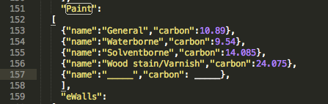

Now fill in those underscores with corresponding data.